**Experiments**

The following block of experiments focuses on the computational costs of the simulator, rather than the outputed states. When designing this application, the major constraint I faced was the computational complexity. Abiding by the base specifications, it’s nearly impossible to compute past a depth of 3. Adding in additional resources and transformations exponentially increases the computation time. Thus, the design of the system was fundamentally centered around a configurable way to control and limit this computation complexity. This is what initially led to the development of the parallel search algorithm, and the subsequent extensive development and testing that went into it. A complete list of computational experiments can be found here: <https://docs.google.com/spreadsheets/d/1y05Wkb1zt5lun95TgOKj6Elr2XzQdw_HWGsth6BfBDk/edit?usp=sharing>. Please keep in mind, all computation were run on my work system with the given build:

Cpu: Threadripper 3960x (48 cores)

Ram: 256gb

GPU: 2 * 3090’s (48gb Vram)

Thus, when running the same computations, especially in parallel, the results will most likely be significantly slower.

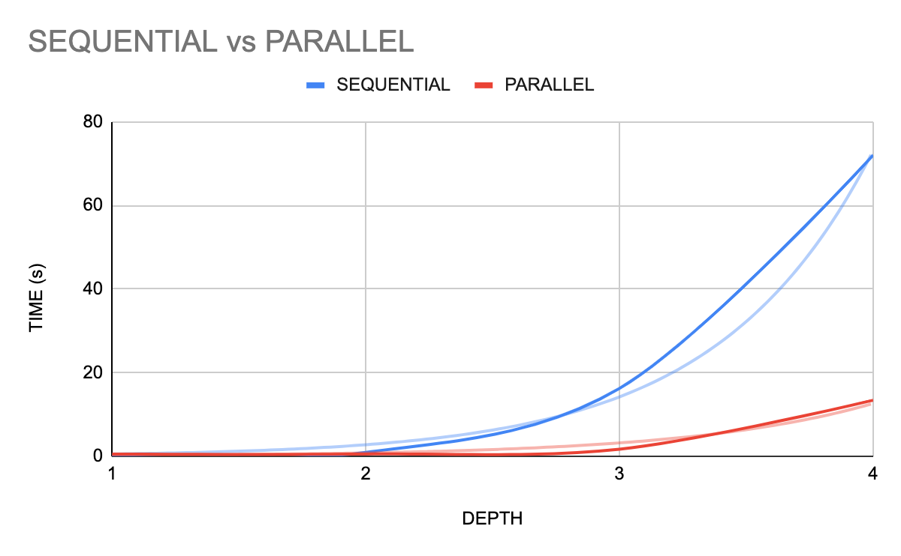

*Parameters*

State Reduction: -1

Frontier Size: 1000

Solution size: 3

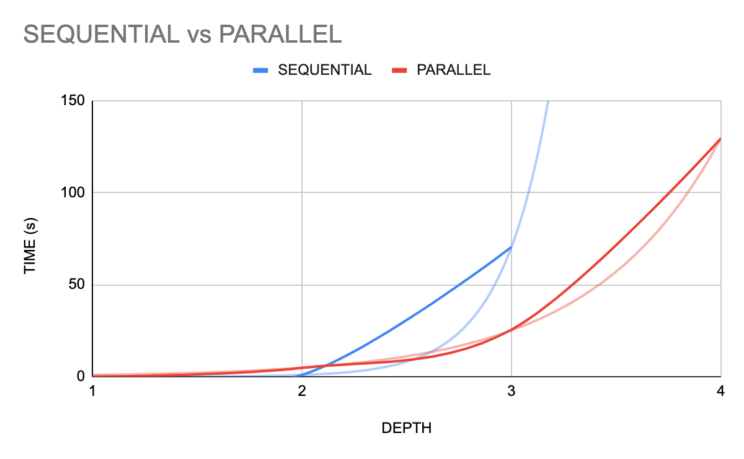

*Parameters*

State Reduction: -1

Frontier Size: 10000

Solution size: 3

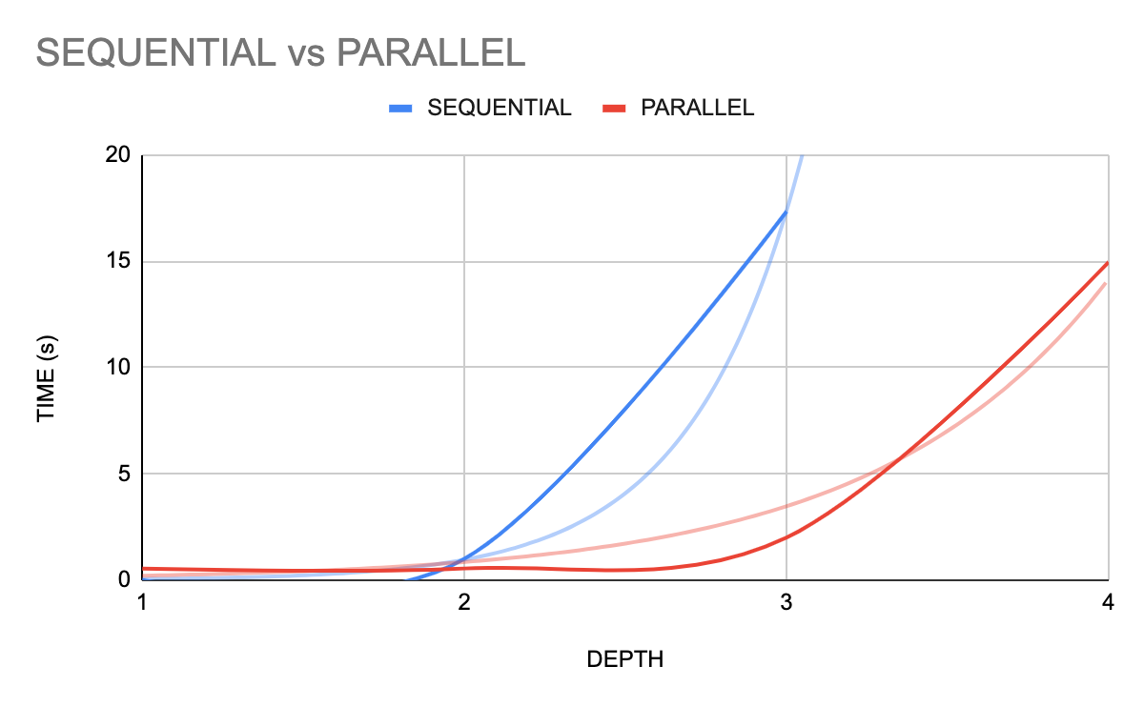

*Parameters*

State Reduction: -1

Frontier Size: 1000

Solution size: 10000

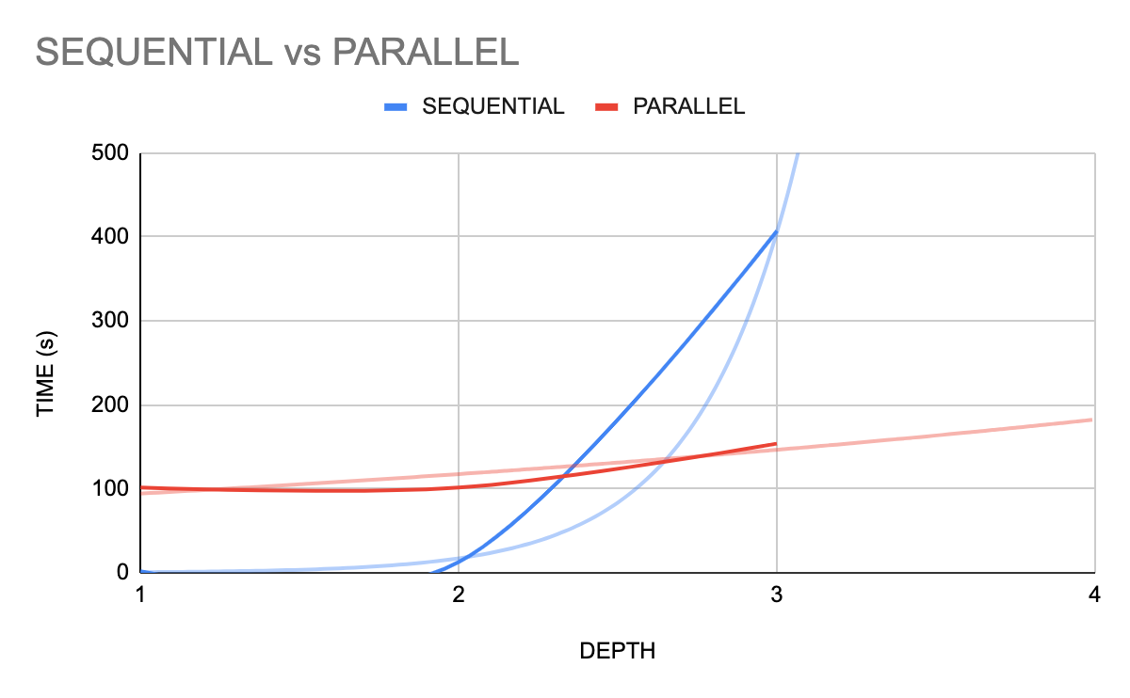

*Parameters*

State Reduction: 1

Frontier Size: 1000

Solution size: 10000

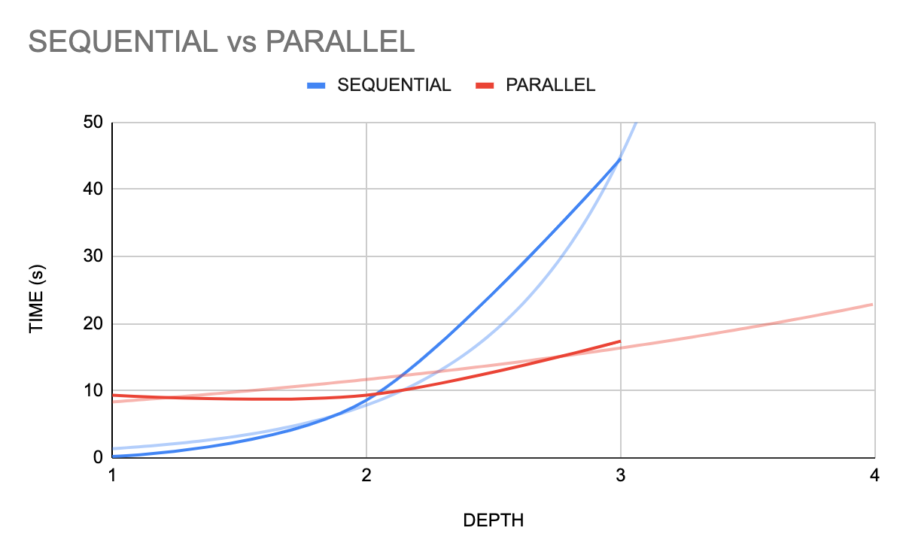

*Parameters*

State Reduction: 10

Frontier Size: 1000

Solution size: 10000

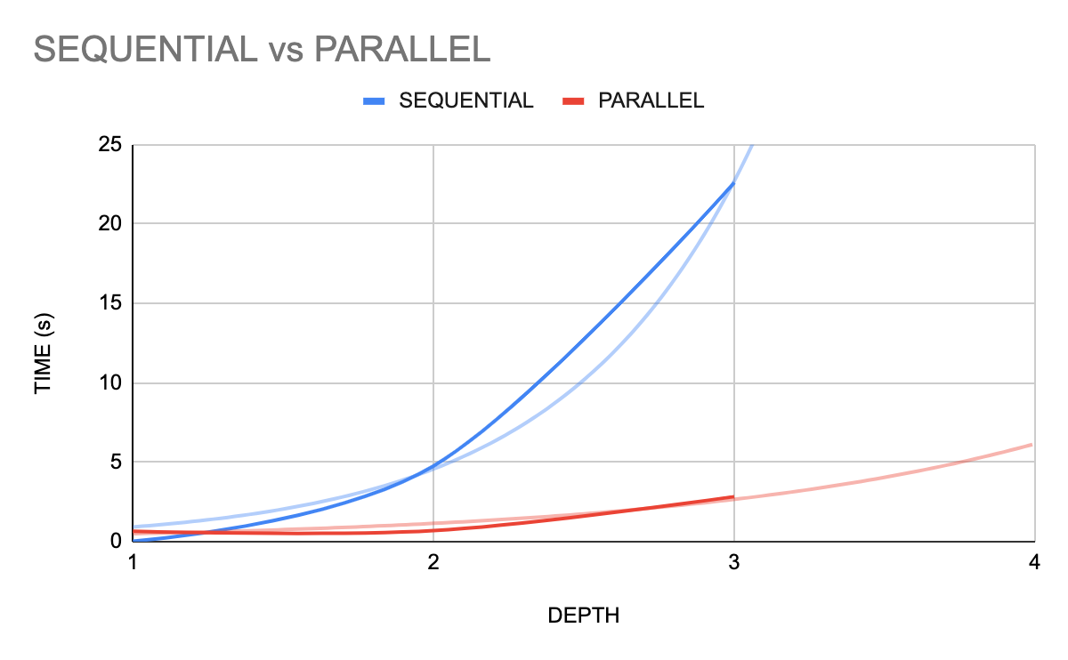

*Parameters*

State Reduction: 100

Frontier Size: 1000

Solution size: 10000

In summary, every perceriable performance test showed an exponential difference between the sequential and parallel computations. Theoretically, the speed reduction at maximum should be a linear factor of the number of cpus available to the system. Thus, for this given system, there should be a hard limit of a 48x speed up. However, due to the innate beam search implemented in the internal chunking of the parallel system, there is a further reduction of searched states. This, in combination with the fundamental parallel speed, allowed for an exponential decrease in speed, rather than just a linear one.

**Test Case 1 - Base Level**

*Parameters*

Depth: 4

Gamma: 0.8

State Reduction: -1

Frontier Size: 1000

C: 0.1

*Results*

Total States: 18512

Took: 13.359781503677368

Expected Utility for Total Solution: 19702.35

*Analysis*

This test case is meant to set an initial ground truth to compare subsequent test cases off of. The model initially chooses a transfer of land for metallic elements. Initially this doesn’t seem like a smart choice as they are of equal value. However, the model utilizes the extra land it traded for to make a larger farm transform. As farms produce food, farm land is highly valuable, and this sets the model well for the future. The model then decides for another high-value transform: alloy. Finally, the model utilizes it’s previously created farm land for the largest food transform it can make.

Expected Utility for This Action: 19702.354885765082

FOOD TRANSFORM:

INPUTS:

water: 850

farm: 425

OUTPUTS:

food: 85

farm: 425

food_waste: 42

Expected Utility for This Action: 125.44

ALLOY TRANSFORM:

INPUTS:

population: 70

metalic_elm: 140

OUTPUTS:

metalic_alloy: 70

metalic_alloy_waste: 70

population: 70

Expected Utility for This Action: 3776.922

FARM TRANSFORM:

INPUTS:

water: 3400

timber: 1700

available_land: 3400

OUTPUTS:

farm: 1700

farm_waste: 340

Expected Utility for This Action: 23347.348194490132

TRANSFER:

OTHER - SELF

Atlantis - Erewhon

available_land - metalic_elm

4 - 4

| Country | Population | Metalic_Elm | Timber | Available_Land | Water |
| --- | --- | --- | --- | --- | --- |
| Atlantis | 100 | 700 | 2000 | 10000 | 5000 |
| Brobdingnag | 50 | 300 | 1200 | 6000 | 3000 |
| Carpania | 25 | 100 | 300 | 1500 | 750 |
| Dinotopia | 30 | 200 | 200 | 1000 | 500 |
| Erewhon | 70 | 500 | 1700 | 8500 | 4250 |

| Resource | Weight |
| --- | --- |
| Population | 0.1 |
| Metalic_Elm | 0.1 |
| Timber | 0.1 |
| Available_Land | 0.1 |
| Water | 0.2 |
| Metlic_Alloys | 0.4 |
| Housing | 0.5 |
| Electronics | 0.8 |
| Farm | 0.6 |
| Food | 0.8 |
| Metalic_Waste | 0.3 |
| Electronic_Waste | 0.3 |
| Housing_Waste | 0.2 |
| Farm_Waste | 0.1 |
| Food_Waste | 0.1 |

**Test Case 2 - Lower C Value**

*Parameters*

Depth: 4

Gamma: 0.8

State Reduction: -1

Frontier Size: 1000

C: -500

*Results*

Total States: 17352

Took: 12.974365711212158

Expected Utility for Total Solution: 23066.59

*Analysis*

With the decreased value in C comes a higher negative cost of failure for trading. Due to this change, it is evident from the action log that the model compensates for this higher risk by refusing to trade. Rather than risk such a negative outcome, the model has taken a more solitary approach and merely transforms itself utilizing its own initial resources. Once again, the model heavily favors the alloy and farm transform due to the high value of both farm land, food and metallic alloys.

Expected Utility for This Action: 23066.594278600976

ALLOY TRANSFORM:

INPUTS:

population: 70

metalic_elm: 140

OUTPUTS:

metalic_alloy: 70

metalic_alloy_waste: 70

population: 70

Expected Utility for This Action: 4595.712

FARM TRANSFORM:

INPUTS:

water: 3400

timber: 1700

available_land: 3400

OUTPUTS:

farm: 1700

farm_waste: 340

food_waste: 42

Expected Utility for This Action: 31773.007171660793

TRANSFER:

OTHER - SELF

Atlantis - Erewhon

timber - metalic_elm

5 - 5

Expected Utility for This Action: 27371.92091758638

FOOD TRANSFORM:

INPUTS:

water: 850

farm: 425

OUTPUTS:

food: 85

farm: 425

| Country | Population | Metalic_Elm | Timber | Available_Land | Water |
| --- | --- | --- | --- | --- | --- |
| Atlantis | 100 | 700 | 2000 | 10000 | 5000 |
| Brobdingnag | 50 | 300 | 1200 | 6000 | 3000 |
| Carpania | 25 | 100 | 300 | 1500 | 750 |
| Dinotopia | 30 | 200 | 200 | 1000 | 500 |
| Erewhon | 70 | 500 | 1700 | 8500 | 4250 |

| Resource | Weight |
| --- | --- |
| Population | 0.1 |
| Metalic_Elm | 0.1 |
| Timber | 0.1 |
| Available_Land | 0.1 |
| Water | 0.2 |
| Metlic_Alloys | 0.4 |
| Housing | 0.5 |
| Electronics | 0.8 |
| Farm | 0.6 |
| Food | 0.8 |
| Metalic_Waste | 0.3 |
| Electronic_Waste | 0.3 |
| Housing_Waste | 0.2 |
| Farm_Waste | 0.1 |
| Food_Waste | 0.1 |

**Test Case 3 - Lower Food and Farm Value**

*Parameters*

Depth: 4

Gamma: 0.8

State Reduction: -1

Frontier Size: 1000

C: 1

*Results*

Total States: 8251

Took: 4.336463451385498

Expected Utility for Total Solution: 1042.6

*Analysis*

As seen from both previous tests, in the early stages of development, the model will always attempt to optimize food output, and subsequently farm output. This is because both are the two highest values resources in the game, and the ample initial water and land allow for huge EU through farm and food transforms. This experiment drastically reduced the food value. As you can see from the output, with a lowered food value, there is less incentive for farm transforms and the subsequent food transforms. Thus, the model is now favoring alloy and electronic transforms.

Expected Utility for This Action: -40.3577679112646

TRANSFER:

OTHER - SELF

Atlantis - Erewhon

water - available_land

43 - 85

Expected Utility for This Action: 768.7460682959568

ALLOY TRANSFORM:

INPUTS:

population: 70

metalic_elm: 140

OUTPUTS:

metalic_alloy: 70

metalic_alloy_waste: 70

population: 70

Expected Utility for This Action: 613.6544386287145

ALLOY TRANSFORM:

INPUTS:

population: 70

metalic_elm: 140

OUTPUTS:

metalic_alloy: 70

metalic_alloy_waste: 70

population: 70

Expected Utility for This Action: 1042.602185076096

ELECTRONIC TRANSFORM:

INPUTS:

population: 70

metalic_elm: 210

metalic_allot: 140

OUTPUTS:

electronics: 140

electronics_waste: 70

population: 70

| Country | Population | Metalic_Elm | Timber | Available_Land | Water |
| --- | --- | --- | --- | --- | --- |
| Atlantis | 100 | 700 | 2000 | 10000 | 5000 |
| Brobdingnag | 50 | 300 | 1200 | 6000 | 3000 |
| Carpania | 25 | 100 | 300 | 1500 | 750 |
| Dinotopia | 30 | 200 | 200 | 1000 | 500 |
| Erewhon | 70 | 500 | 1700 | 8500 | 4250 |

| Resource | Weight |
| --- | --- |
| Population | 0.1 |
| Metalic_Elm | 0.1 |
| Timber | 0.1 |
| Available_Land | 0.1 |
| Water | 0.2 |
| Metlic_Alloys | 0.4 |
| Housing | 0.5 |
| Electronics | 0.8 |
| Farm | 0.6 |
| Food | 0.1 |
| Metalic_Waste | 0.3 |
| Electronic_Waste | 0.3 |
| Housing_Waste | 0.2 |
| Farm_Waste | 0.1 |
| Food_Waste | 0.1 |

**Test Case 4 - Higher Waste Weights**

*Parameters:*

Depth: 4

Gamma: 0.8

State Reduction: -1

Frontier Size: 1000

C: 1

*Results*

Total States: 4871

Took: 2.836721658706665

Expected Utility for Total Solution: 9299.38

*Analysis*

As is evident from the previous states, the model almost always favors transforms over trades. This is because, as a state reduction technique, the model is only allowed to make even value trades. Thus, the model rarely choses a trade because there is no actual state value gain. To compensate for this, test four drastically increases the waste weight. Thus, while there is still a much larger value gain for developed resources, they come at a higher cost of waste output. With this new weight balance, the model now refuses to transform to avoid the cost of the outputed weight.

Expected Utility for This Action: -5.039664093522874

TRANSFER:

OTHER - SELF

Dinotopia - Erewhon

metalic_elm - timber

2 - 2

Expected Utility for This Action: -23.564223654418807

TRANSFER:

OTHER - SELF

Dinotopia - Erewhon

water - available_land

43 - 85

Expected Utility for This Action: -19.744218324849438

TRANSFER:

OTHER - SELF

Dinotopia - Erewhon

water - available_land

43 - 85

Expected Utility for This Action: -4.71247620242868

TRANSFER:

OTHER - SELF

Carpania - Erewhon

metalic_elm - timber

1 - 1

| Country | Population | Metalic_Elm | Timber | Available_Land | Water |
| --- | --- | --- | --- | --- | --- |
| Atlantis | 100 | 700 | 2000 | 10000 | 5000 |
| Brobdingnag | 50 | 300 | 1200 | 6000 | 3000 |
| Carpania | 25 | 100 | 300 | 1500 | 750 |
| Dinotopia | 30 | 200 | 200 | 1000 | 500 |
| Erewhon | 70 | 500 | 1700 | 8500 | 4250 |

| Resource | Weight |
| --- | --- |
| Population | 0.1 |
| Metalic_Elm | 0.1 |
| Timber | 0.1 |
| Available_Land | 0.1 |
| Water | 0.2 |
| Metlic_Alloys | 0.4 |
| Housing | 0.5 |
| Electronics | 0.8 |
| Farm | 0.6 |
| Food | 0.2 |
| Metalic_Waste | 100 |
| Electronic_Waste | 400 |
| Housing_Waste | 300 |
| Farm_Waste | 300 |
| Food_Waste | 100 |

**Test Case 5 Lower Starting Land Amounts**

*Parameters*

Depth: 4

Gamma: 0.8

State Reduction: -1

Frontier Size: 1000

C: 1

*Results*

Total States: 9655

Took: 5.094475984573364

Expected Utility for Total Solution: 1042.6

*Analysis*

As seen from the previous tests, the model heavily favors food and farm transforms for their high value. The model is able to further compound the EU of a state with the large amount of initial water and land it receives. To help balance this inequality, this test was run with significantly reduced starting amounts of land and water. Thus, while still weighted heavier, the model was not able to make as large of transforms. To compensate for this, the model instead favored the alloy and electronic transform for their next highest resource value and starting amount.

Expected Utility for This Action: -9.895824505770381

TRANSFER:

OTHER - SELF

Atlantis - Erewhon

water - metalic_elm

4 - 8

Expected Utility for This Action: 768.7460682959568

ALLOY TRANSFORM:

INPUTS:

population: 70

metalic_elm: 140

OUTPUTS:

metalic_alloy: 70

metalic_alloy_waste: 70

population: 70

Expected Utility for This Action: 613.6544386287145

ALLOY TRANSFORM:

INPUTS:

population: 70

metalic_elm: 140

OUTPUTS:

metalic_alloy: 70

metalic_alloy_waste: 70

population: 70

Expected Utility for This Action: 1042.602185076096

ELECTRONIC TRANSFORM:

INPUTS:

population: 70

metalic_elm: 210

metalic_allot: 140

OUTPUTS:

electronics: 140

electronics_waste: 70

population: 70

| Country | Population | Metalic_Elm | Timber | Available_Land | Water |
| --- | --- | --- | --- | --- | --- |
| Atlantis | 100 | 700 | 2000 | 10000 | 5000 |
| Brobdingnag | 50 | 300 | 1200 | 6000 | 3000 |
| Carpania | 25 | 100 | 300 | 1500 | 750 |
| Dinotopia | 30 | 200 | 200 | 1000 | 500 |
| Erewhon | 70 | 500 | 10 | 100 | 400 |

| Resource | Weight |
| --- | --- |
| Population | 0.1 |
| Metalic_Elm | 0.1 |
| Timber | 0.1 |
| Available_Land | 0.1 |
| Water | 0.2 |
| Metlic_Alloys | 0.4 |
| Housing | 0.5 |
| Electronics | 0.8 |
| Farm | 0.6 |
| Food | 0.2 |
| Metalic_Waste | 100 |
| Electronic_Waste | 400 |
| Housing_Waste | 300 |
| Farm_Waste | 300 |
| Food_Waste | 100 |